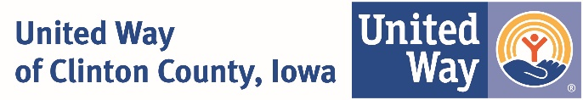

NEWS RELEASE Local Contact: Cheryl S. McCulloh
FOR IMMEDIATE RELEASE 563-242-1209 director@clintonunitedway.org

United Way of Clinton County, Iowa Planning $650,000 Campaign

Rich Klahn, Assistant Vice President with Clinton National Bank, and Julie Witt, Office Service Manager with ACI, will lead this fall’s United Way campaign to raise $650,000.
“The United Way campaign is where it all starts,” said Klahn. “We can’t help people who need help if the necessary funds aren’t available. I was born and raised in Clinton County and I care deeply about the people here. We step up in times of need.”
United Way focuses on improving the health, education, and financial stability of area residents. All children need a strong start in life, and the support to successful in school and work. People need the education and tools to secure a job that supports them and their family throughout a lifetime. Individuals and families that have healthier beginnings and healthier lives build strong communities with a good quality of life.
Julie Witt added, “I’ve seen people in my own neighborhood who needed help. United Way programs help so many people with basic necessities and skills needed to succeed in life, and none of it would be possible without the generous support of Clinton County residents.”
“United Way is fortunate to have Rich and Julie lead this year’s campaign. Both have a strong personal commitment to improving our community and helping people,” said Cheryl McCulloh, Executive Director of United Way of Clinton County, Iowa.
This year’s United Way campaign details will be announced at the official kickoff, scheduled for Sept. 19. For more information, visit clintonunitedway.org

#######

